Wet N Cool
2013

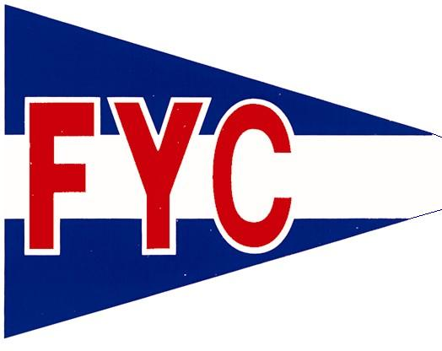

We hope you all will plan to attend the annual Junior Wet N Cool Regatta in Fairhope
April 6-7

We are hosting a cookout on Saturday evening with a bonfire, smores, outdoor movie, and a campout on the beach!

Bring your tent and sleeping bags and join us if you can!

Call or email Mikeal or Brenda if you have any questions: Mikeal – mdonald@me.com 251-454-4381.
Brenda – rhumbline1@att.net 251-928-0340

